
NOTE: This is an official document by Indexademics. Unless otherwise stated, this document may not be accredited to individuals or groups other than the club IDX, nor should this document be distributed, sold, or modified for personal use in any way.
IDX G9 Physics S+ STUDY GUIDE ISSUE 7
By Virginia and Joyce

Two kind of masses
Chapter 7 – Two Kinds of Mass & Einstein’s Theory of Gravity

1. Two Types of Mass

A. Inertial Mass

• What is it?
Inertial mass measures how much an object resists a change in motion when a force is applied.
Think of it as how “stubborn” an object is when you try to push it.

• How to measure it?
You apply a force to the object and measure how much it accelerates.
• Formula:
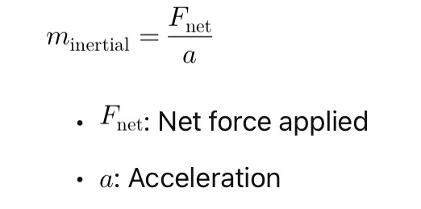

• Example:
If you push two objects with the same force, the heavier one (larger inertial mass) will accelerate less.

B. Gravitational Mass

• What is it?
Gravitational mass tells us how strongly an object interacts with the force of gravity.
• How to measure it?
Use a balance scale (like when you weigh something on Earth).
• Formula (from Newton’s Law of Universal Gravitation):

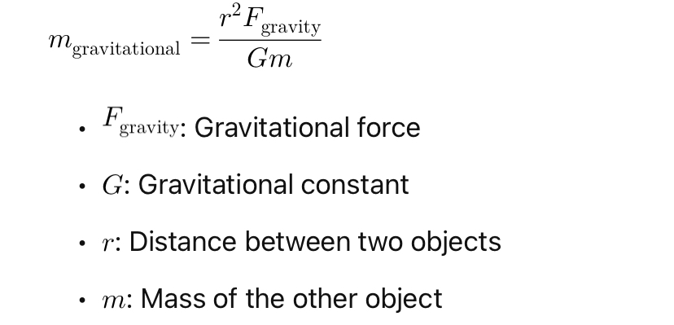

C. Are These Two Masses the Same?

Yes! According to the Principle of Equivalence, inertial mass = gravitational mass.
Einstein used this idea as the foundation for his theory of gravity.

2. Einstein’s Theory of Gravity

A. Gravity is Not a Force (in Einstein’s view)

• Einstein said gravity isn’t a pulling force like Newton thought.
• Instead, mass bends space, and objects move along this curved space.

